**For Contact Us Page**

User should not be able to edit it, only trace and copy.

Currently, the user is able to edit the contact us page. (the keyboard bar shows up and it should not show up)

Make it that the user can only trace and copy texts.

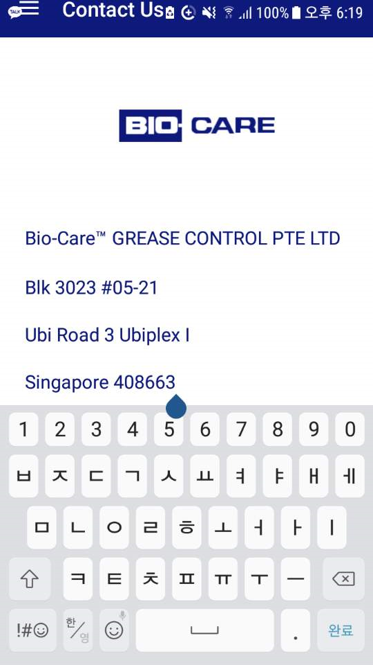

Rep: Working on this. Will fix it ASAP.

**For Start Work Page**

After the user submits the remarks and presses the submit button, it goes back to the Scheduled Bookings Page. However, there is a back button instead of the hamburger button on the top left(Beside the Bookings text).

User should not be able to go back or press the arrow button.

Remove the arrow button on the top left since the Submit Button should lead to the normal Scheduled Bookings Page with the hamburger button on the top left (not the arrow button).

Rep: Have corrected it. Please check

**For Reminders Page**

After user submits the save button it has the arrow button like the start work page. (similar to start work page)

Rep: Have corrected it. Please check

*Have you mentioned that this will be fixed after the integration?